**3.AWS-VPC-Subnets-IGW-RT-Routes-SG-KeyPair**

--- **QUES what is public cloud…?**

Aws, Azure, google cloud are public cloud. On the public platform anyone can create resources.

When I say resources, it means EC2 instances, S3 bucket, Networking, firewall ...etc. this public platform is not dedicated for you only, it can used by anyone.

**--- QUES What is private cloud…?**

Who needs heavy secure environment, they needs to create their own data centre. Some companies create their own data centres for their employees, they also seems to be same like public platform. Eg openstack..

--- **QUES What is hybrid cloud…?**

if you merge your private cloud with public cloud is called hybrid cloud.

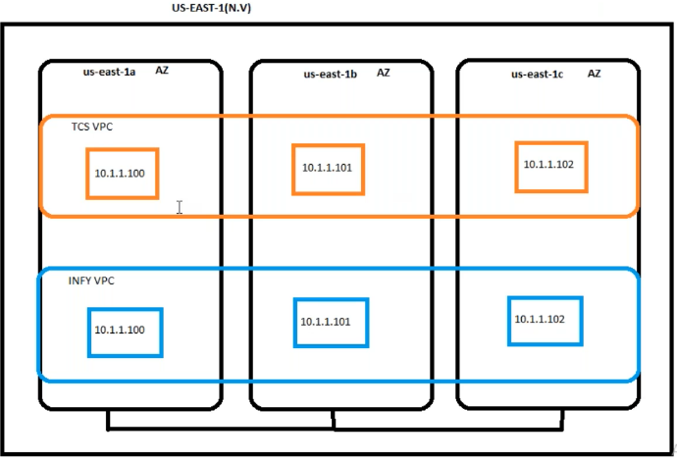

--- the availability zone is your data center.

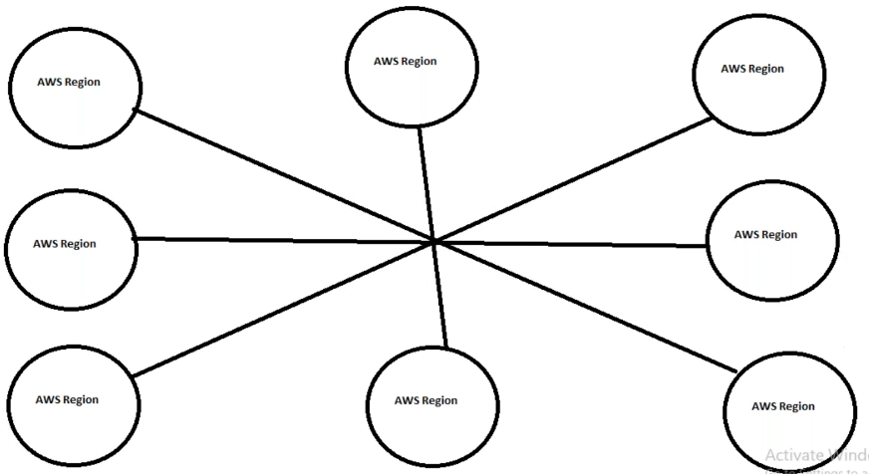

--- All region is internally linked in the back end. All AWS regions connected in the back end, only you need to establish the connection if needed.

**1.Vpc creating**

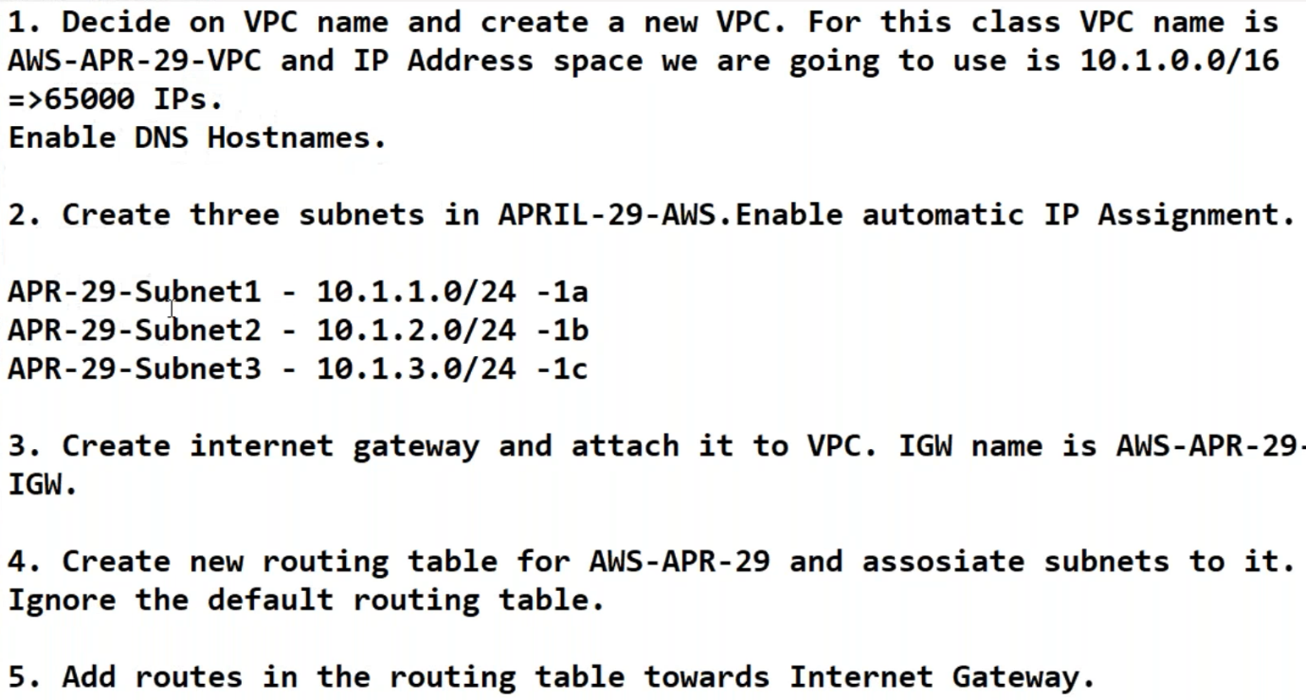

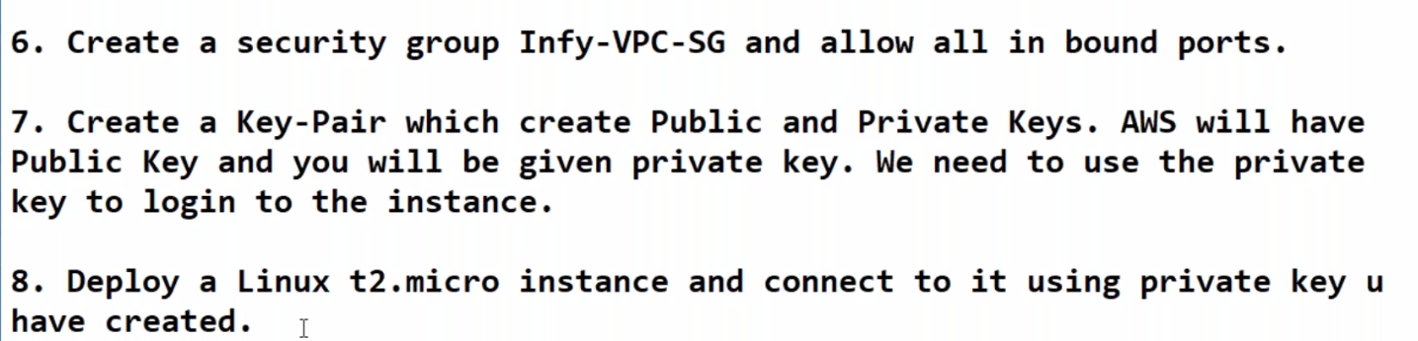

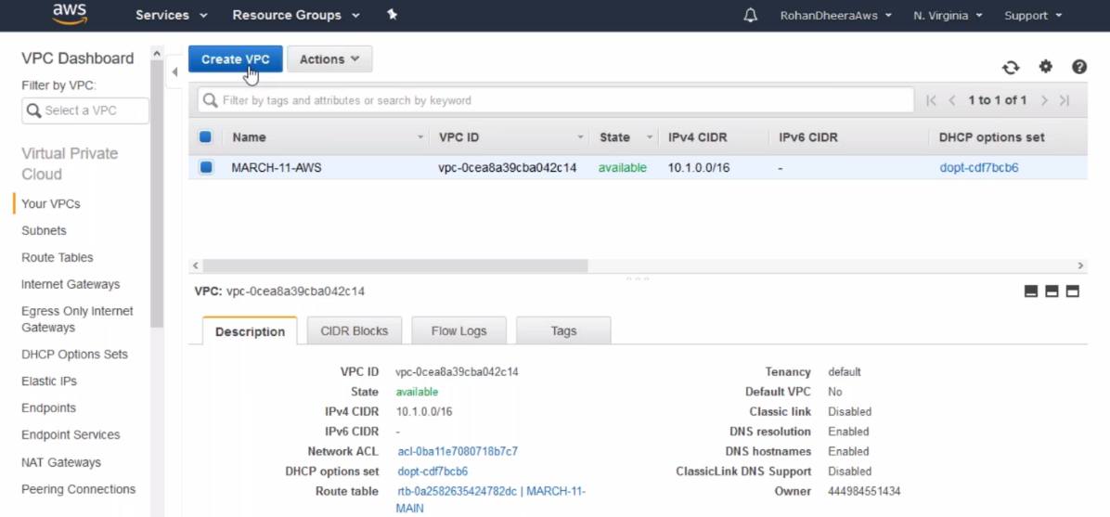

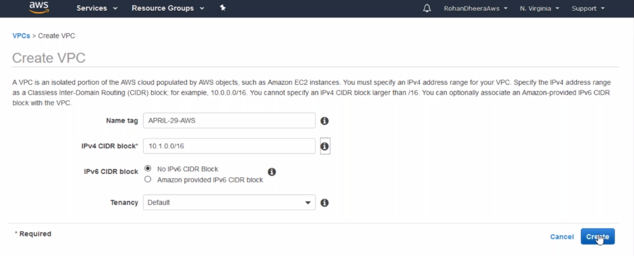

--- you can give maximum 28

**Edit DNS hostname**

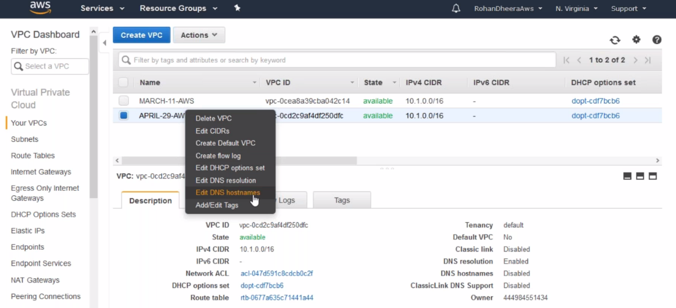

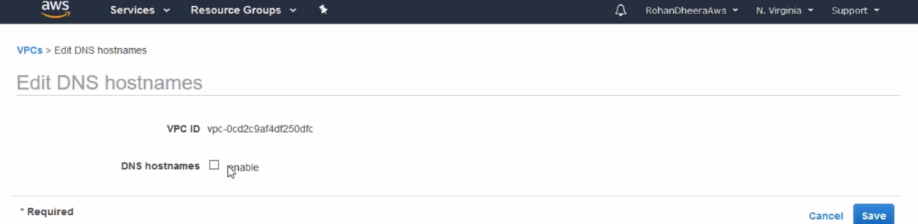

**2.Subnet creating**

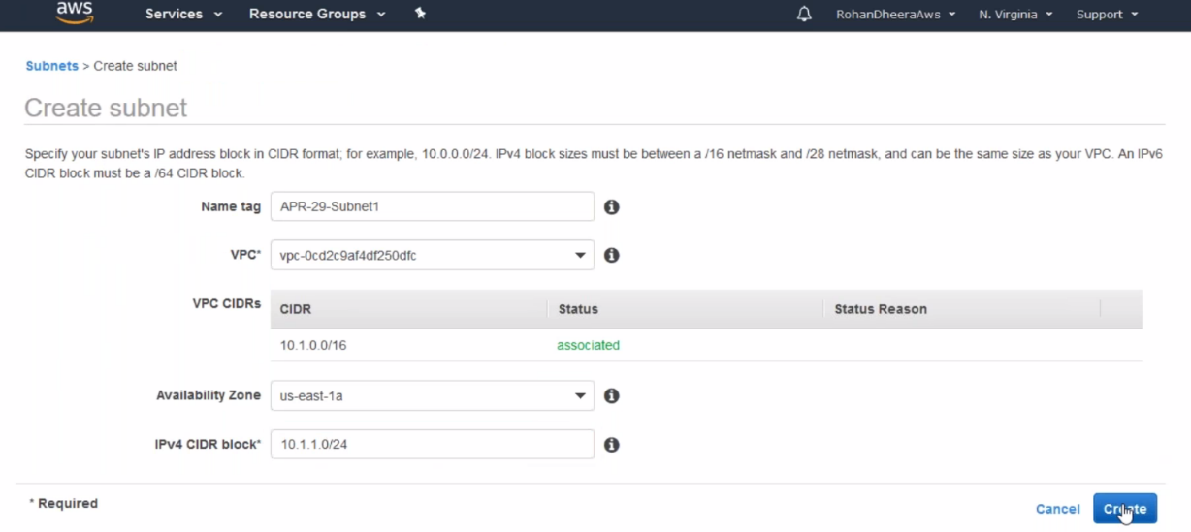

--- riht click on subnet and give auto assign ip address.

**3.Creating IG( internet gate way )**

the IGW will allow the traffic from the inside to out and outside to inside. Its act as Nating.

--- **QUES – I created a gatway but I cannot attach. what is the reason?**

Now you have to ask him like which gatway u r taking about . he mentioned IGW, tell him that the IGW is detached mode you have to attach manually. And also 1 IGW for 1 vpc.

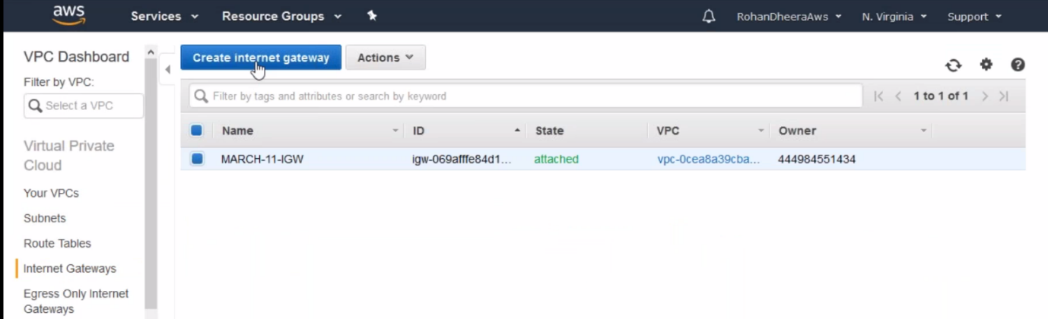

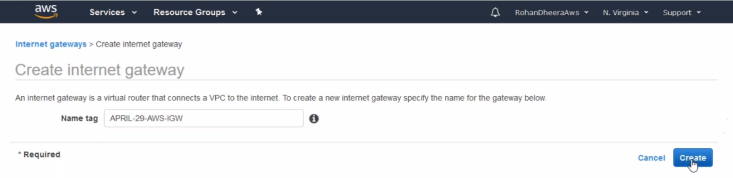

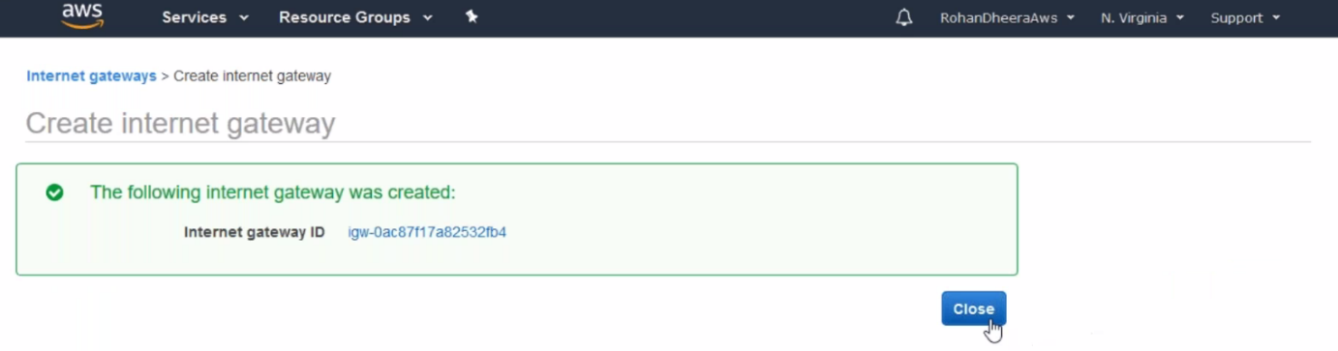

--- initially the internet gate way is in detached mode we need to attach it to the VPC.

**4. Routing Table (it decides the traffic flow) Creating**

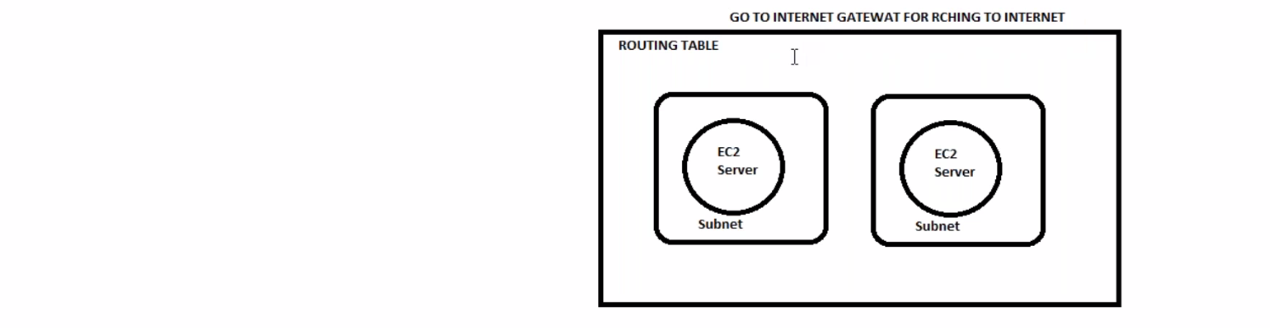

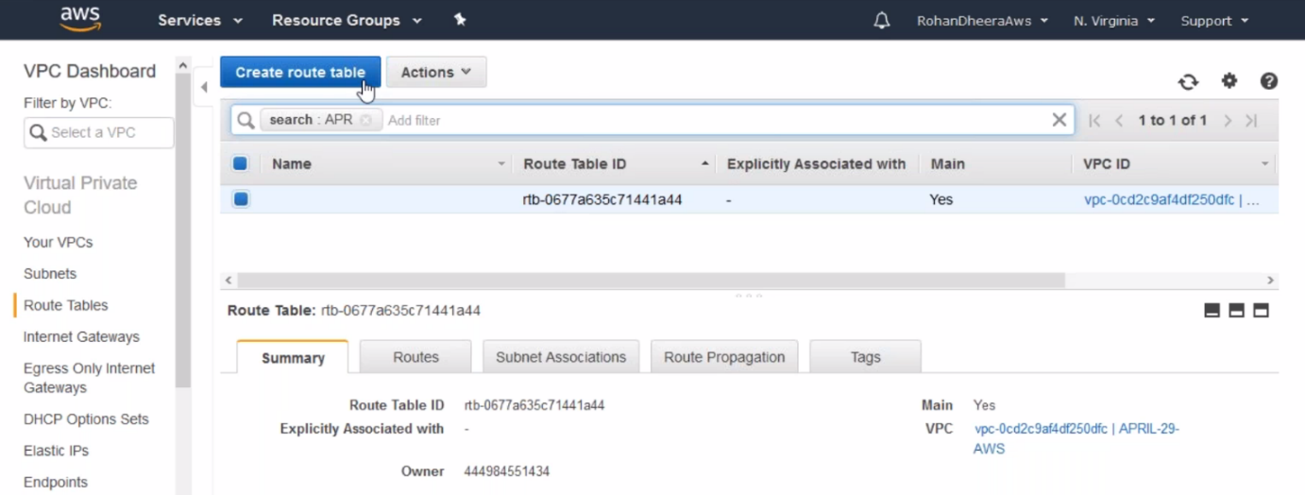

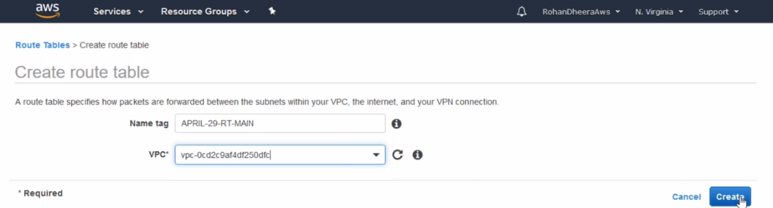

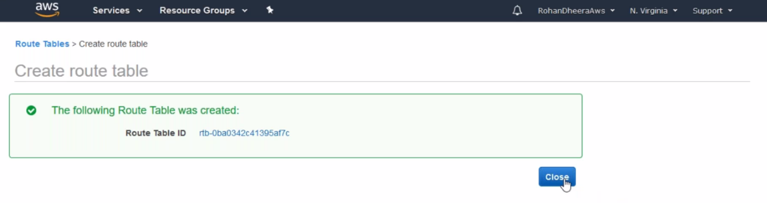

**Subnet association**

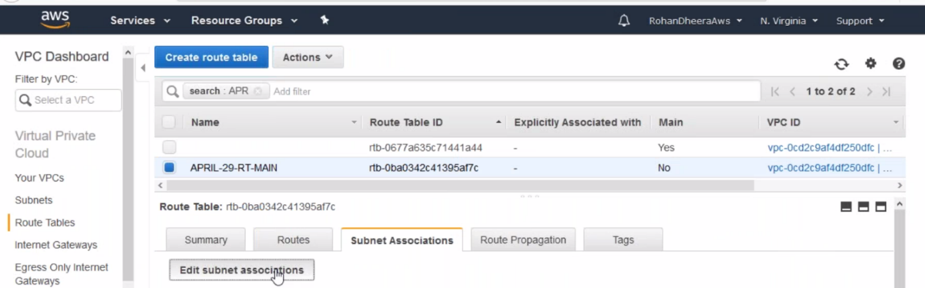

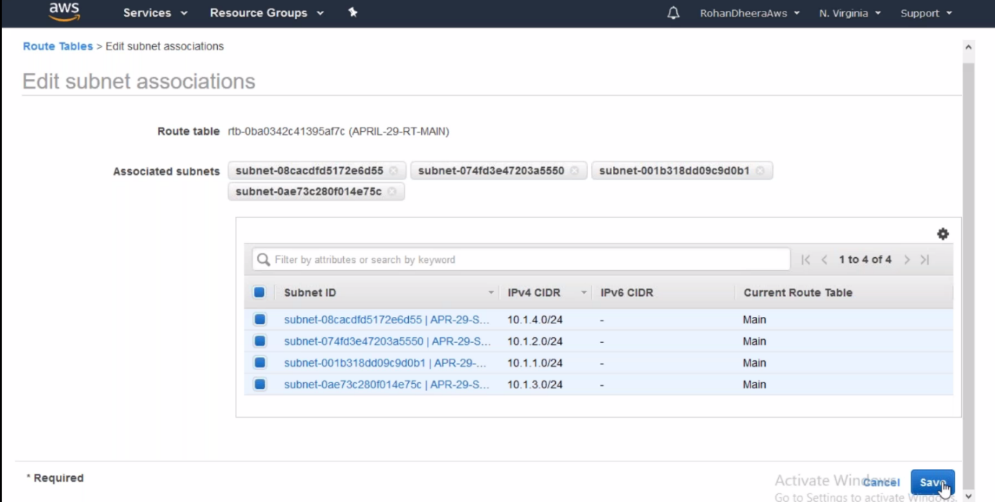

--- add all subnets to the routing table. Here all the subnets with in the routing table using this routing table.

**Routes**

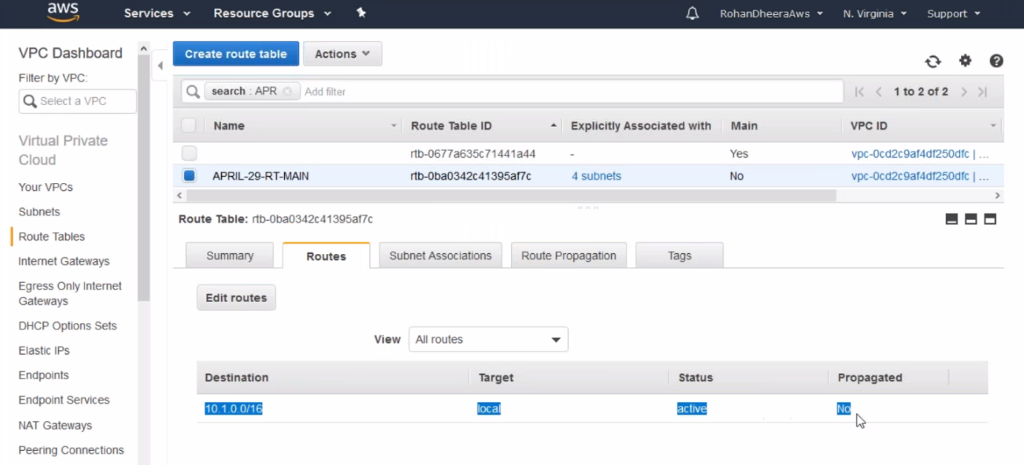

--- by default, we have only local route and click on edit routes option.

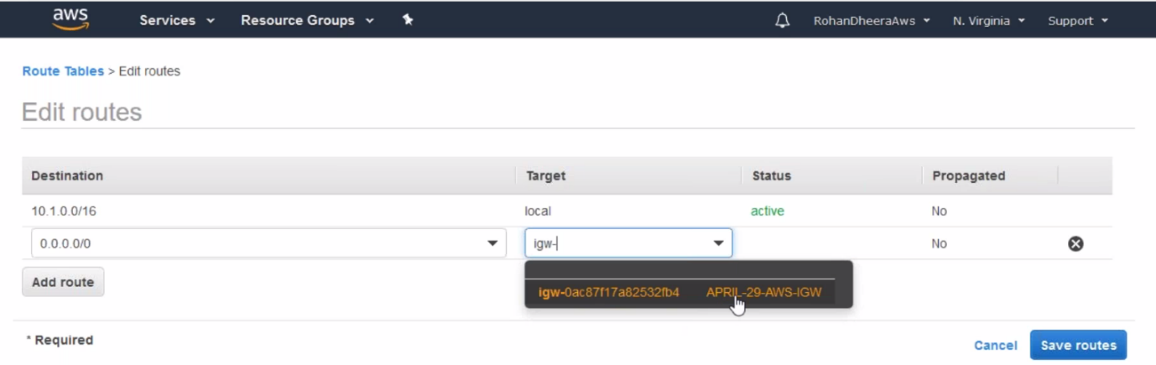

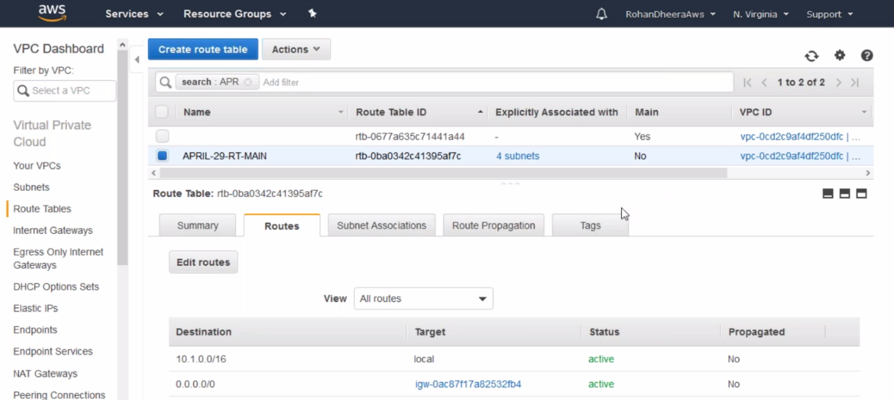

--- we have successfully added the IG in the routes

**5.Security Group Creating**

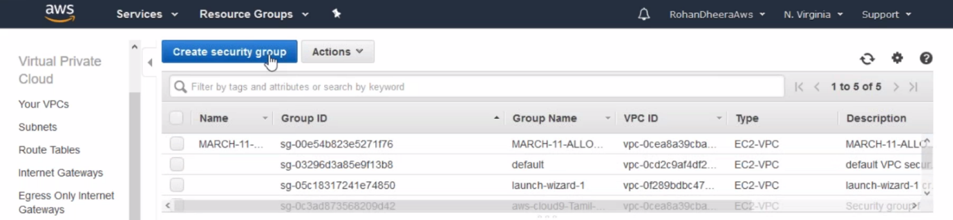

--- click on create security group.

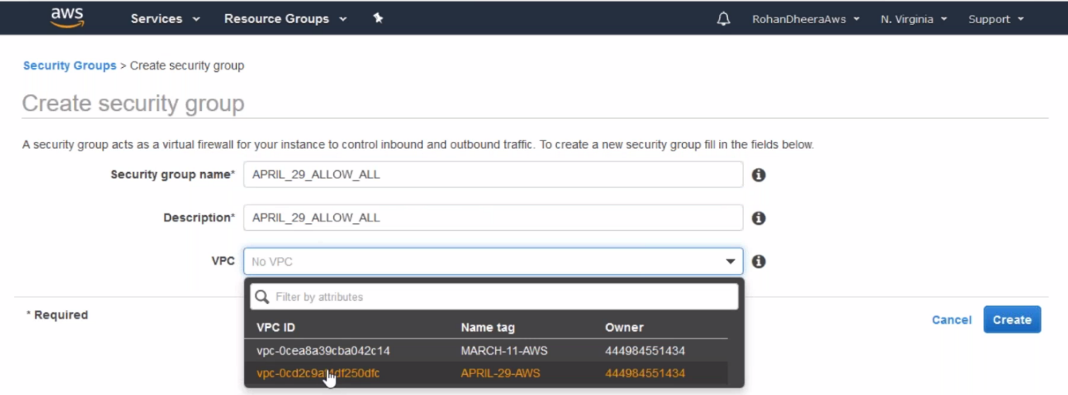

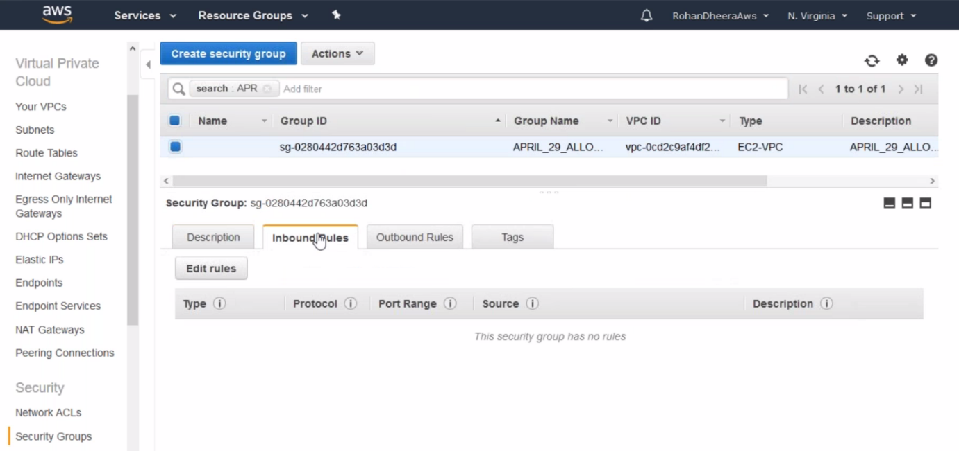

--- initially we have inbound and outbound rules.

--- edit inbound rules.

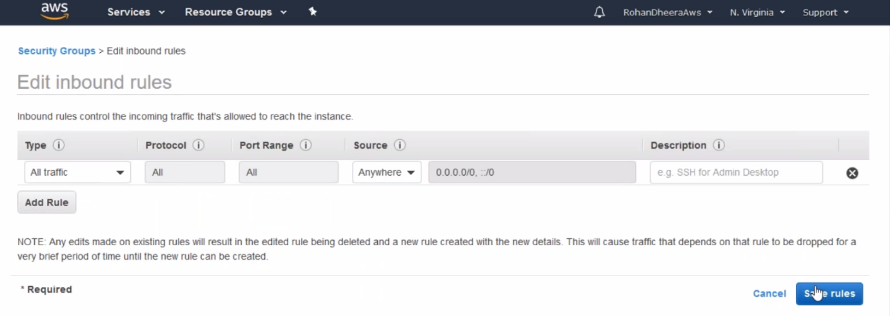

--- save the rule.